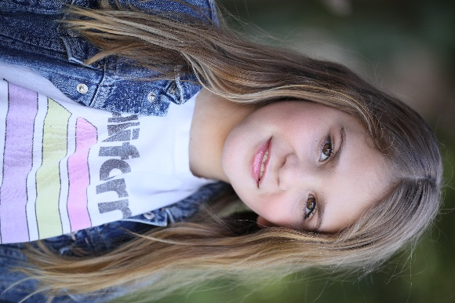
Allie Grace Brady

Height: 4’4 Tower Talent Studio West
Weight: 79lbs San Diego, CA 92126
Eye Color: Brown 858-824-0700
Hair Color: Blonde Mom’s email: netnee1985@gmail.com
DOB: 4/20/17 Mom’s phone number: 619-994-0356

Stage Experience
National American Miss State Pageant Scottsdale, AZ- July 2024, June 2025
Willy Wonka Performance- Jamul Elementary San Diego, CA- Nov 2024
National American Miss Nationals Pageant Orlando, FL- Nov 2024
Beauty and the Beast Performance- Jamul Elementary San Diego, CA- May 2025
Photoshoot- Play City Grand Opening San Diego, CA- May 2025

Training:
Acting- Tower Talent Studio West San Diego, CA
Modeling- Tower Talent Studio West San Diego, CA
Interviewing- National American Miss
Public Speaking- National American Miss

Hobbies/Sports-
Dance, Gymnastics, Basketball, Gardening, Art Smarts, NAM Pageants, Acting, Modeling

Awards
1st Runner up -Dream Model- National American Miss State Pageant- CA 2024
2nd Runner up- Casual Wear- National American Miss State Pageant- CA 2024
National Ambassador Title- National American Miss Nationals Pageant- Orlando, FL 2024
1st place- Runway- National American Miss State Pageant, CA 2025
1st place- Dream Model- National American Miss State Pageant- CA 2025
1st Runner up- Actress- National American Miss State Pageant- CA 2025
1st Runner up- Top Model photoshoot- National American Miss State Pageant- CA 2025
2nd Runner up- Casual Wear- National American Miss State Pageant- CA 2025
Semi Finalist, CA State Queen- National American Miss State Pageant- CA 2025
Perfect Attendance- All of 2025
Most Improved- Reading and Math- 2nd grade

